**2022.01.20 Rydberg Constant**

**Start Time:** circa 09.00

Aim

An experiment was carried out to measure the wavelength of light emitted from a hydrogen lamp caused by the de-excitation of an electron from n *(initial energy level of an electron)* to p *(final)*, through the measurement of the angle the eyepiece forms to the normal, taking note of the minima order. This is done using a diffraction grating and spectrometer. By plotting this against obtained through the comparison of the observed colour to the known colour emission from the Balmer series - the gradient of this graph gives the Rydberg constant.

Background

This experiement makes use of a diffraction grating in the spectrometer. The path difference for a diffraction grating with *N* equally spaced narrow slits, slit separation *d*, is defined by:

phase difference is charaacterised by an integer value of *m,* the order number of the maxima; λ gives the wavelength of incoming light.

Therefore, substituting in that the path difference of , the wavelength of the emitted photon *(λ)* can consequently be obtained.

It is given by ; this is directly related to the amount of kinetic energy that is released from the de-excitation of an electron in a hydrogen atom from a given energy level *n* to *p,* with larger energy level drops corresponding to more energy being released by the electron as a photon - this in term corresponds to a higher frequency. The equation relating λ to n and p is given by:

We have that the Rydberg constant is defined by the following equation:

me is the mass of the electron, c = speed of light, h = Planck’s constant, α = fine-structure constant

We therefore, have that 1/α ≈ 137.0 (dimensionless constant), substituting all of these constants in.

Description of Set-Up

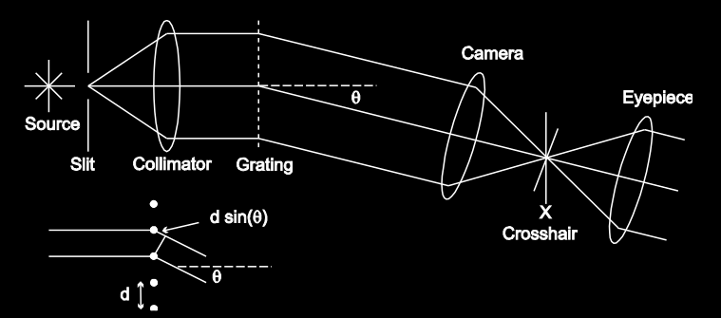

Figure 1: Mangles et. al, 2021 , a diagram of the set-up of the spectrometer used

**N.B:** Dials on the spectrometer going from right to left, control:

telescope focus knob - controls how focused image is, already at “infinity” - a really, far away location

telescope rotation knob 1 - adjust large rotations

telescope rotation knob 2 - adjust minute rotations, in order to get crosshair at maximum

bottom knob - locks the telescope in place, allows rotation of the grating holder stage

height adjustment screw - adjusts height of mirror

fine adjustment screw - fine adjustment of mirror

slit width screw - adjust the slit width

**Calibration of Spectrometer**

The telescope was focused onto the image of a distant object onto the crosshair through the rotation of the focus knob (we used a post-it note next to a poster in the adjacent room, about 20 metres away). Following this, the sodium lamp was turned on.

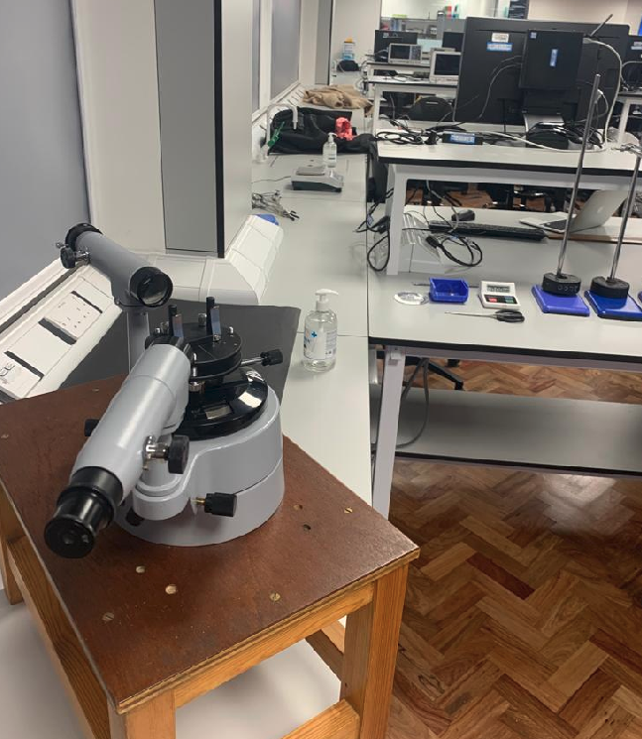

Figure 2: focusing the telescope on distant object

The telescope was aligned with the axis of the collimator, and the slit width screw adjusted till there were bright and sharp images of the slit at the cross hair. Once this alignement had happened, we took the initial position readings using the vernier scale (where the bottom scale increments were in half-degrees, and the top scale ones were in arc-minutes, or 1/60th of a degree).

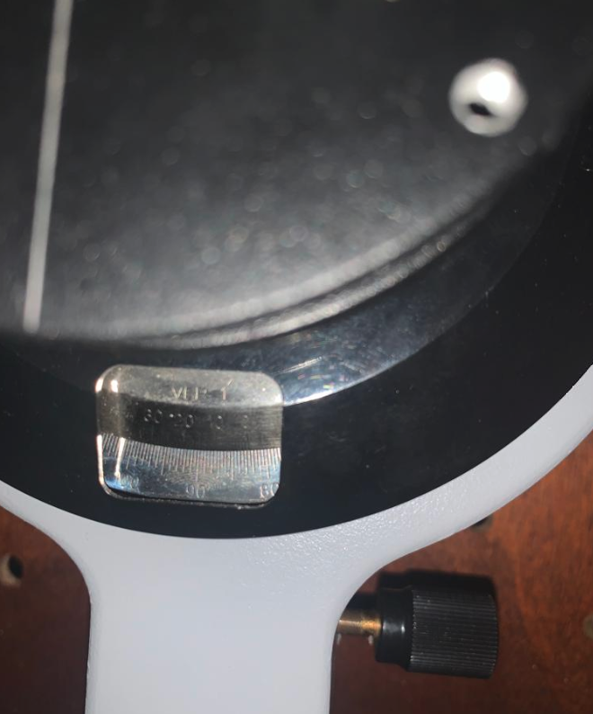

Figure 3: reading the vernier scale

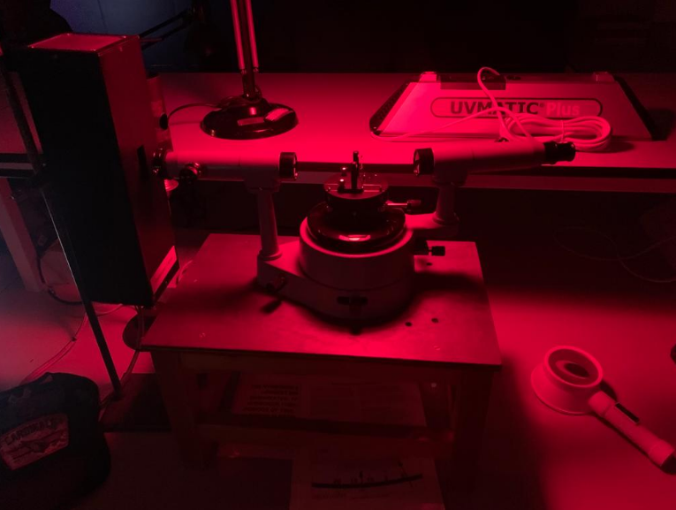

**INITIAL READING:**

|  |  |  |  |
| --- | --- | --- | --- |
|  | **LOWER** | **UPPER** |  |
|  | **degrees** | **minutes** | **combined** |
| **initial** | 122.5 | 7 | 122.6166667 |

We then rotated the telescope through 90° fixing its position, resulting in the following angle:

**ROTATED READING BY 90°:**

|  |  |  |
| --- | --- | --- |
| **rotations** |  | 32.11666667 |

Then, the mirror was placed onto the grating holder. The telescope was kept fixed whilst the grating table was rotated with the mirror, such that the reflected image of the entrance slit was centered through the eyepiece, making an angle of 45° relative to the incident beam.

**ROTATED READING BY 45°:**

|  |  |
| --- | --- |
| **rotations** | 77.11666667 |

After this, the height of the image was adjusted using the screws under the grating table; the slit image was centered onto the crosshair using the grating driver. The mirror was then rotated until it was normal to the incident light (by 45°). The sodium lamp was replaced with a hydrogen lamp **(don’t leave on too long, or it will burn out!!!!)**

**CENTRAL MAXIMUM LOCATION**

|  |  |  |  |
| --- | --- | --- | --- |
| 0 | 167 | 4-10 | 167.0666667 |

Then, we replaced the mirror with 2 different diffraction gratings, testing the alignment of the hydrogen lamp through inspection of the central maximum using the telescope and making sure each maxima either side of the central maxima were roughly symmetrical in position. We then proceeded to test 2 different gratings.

* 78.8 lines per mm: closer together (increases percentage uncertainty of angle measurements), but larger emission lines, and more maxima
* 300 lines per mm: further apart, but fewer minima, thinner emission lines hard to identify

Consequently, the 78.8 lines per mm grating was selected - more, clearer readings which are more easily identifiable would be obtained. By getting a larger number of maxima, this would have more of an impact that the said-reduction in percentage uncertainty.

Measurement Strategy, Uncertainties

Rotate the cross-hair to form an X rather than a + as this is more easily identifiable when trying to align it with the maxima. Measure the angle of the central maxima.

**CENTRAL MAXIMUM LOCATION**

|  |  |  |  |
| --- | --- | --- | --- |
| 0 | 167 | 4-10 | 167.0666667 |

We took a few preliminary readings to estimate the uncertainty associated with each measurement for the maxima. We came to the conclusion that each maxima had roughly ± 3 arcminutes in total associated with it, also taking into account the vernier scale uncertainty (aided with a phone camera, along with a magnifying glass):

|  |  |  |  |  |  |  |  |  |  |
| --- | --- | --- | --- | --- | --- | --- | --- | --- | --- |
| **m** |  |  |  |  |  |  |  |  |  |
| 0 | 167 | 4 | 167.0666667 |  | 0 | 167 | 10 | 167.1666667 | 167.1166667 |
| -1 | 164 | 4 | 164.0666667 |  | -1 | 164 | 10 | 164.1666667 | 164.1166667 |

Thus, we took into account this uncertainty in the angle into our calculations.

Additionally, systematic uncertainties could arise from misalignment, background light, defocus, and the position of the lamp. [Source: Mangles et al, 2021, Year 1 Laboratory Manual: Spectrometry, Imperial College London]. Systematic uncertainties do not affect the gradients calculated from the graphs.

Care was taken to ensure that the hydrogen lamp didn’t burn out - it was only turned on whilst measurements were being made. This is also made sure emission lines were as visible as possible.

Data Analysis

|  |  |  |  |  |  |  |  |  |  |  |  |  |
| --- | --- | --- | --- | --- | --- | --- | --- | --- | --- | --- | --- | --- |
| **m** | **degrees** | **minutes** | **angle/°** | **angle from central maxima/°** | **angle from central maxima/rad** | **sin(angle)** |  | **minimum fringe angle/rad** | **maximum fringe angle/rad** | **sin(min angle)** | **sin (angle)** | **sin(max angle)** |
| **Red** |  |  |  |  |  |  |  |  |  |  |  |  |
| 1 | 170 | 7 | 170.1 | 3.00 | 0.0524 | 0.0523 |  | 0.0515 | 0.0532 | 0.0515 | 0.0523 | 0.0532 |
| 2 | 173 | 4 | 173.1 | 5.95 | 0.1038 | 0.1037 |  | 0.1030 | 0.1047 | 0.1028 | 0.1037 | 0.1045 |
| 3 | 176 | 4 | 176.1 | 8.95 | 0.1562 | 0.1556 |  | 0.1553 | 0.1571 | 0.1547 | 0.1556 | 0.1564 |
| 4 | 179 | 10 | 179.2 | 12.05 | 0.2103 | 0.2088 |  | 0.2094 | 0.2112 | 0.2079 | 0.2088 | 0.2096 |
| 5 | 182 | 14 | 182.2 | 15.12 | 0.2638 | 0.2608 |  | 0.2630 | 0.2647 | 0.2599 | 0.2608 | 0.2616 |
| 6 | 185 | 26 | 185.4 | 18.32 | 0.3197 | 0.3143 |  | 0.3188 | 0.3206 | 0.3134 | 0.3143 | 0.3151 |
| 0 | 167 | 7 | 167.1 | - | 0.0000 | 0.0000 |  | -0.0009 | 0.0009 | -0.0009 | 0.0000 | 0.0009 |
| -1 | 164 | 7 | 164.1 | -3.00 | -0.0524 | -0.0523 |  | -0.0532 | -0.0515 | -0.0532 | -0.0523 | -0.0515 |
| -2 | 161 | 7 | 161.1 | -6.00 | -0.1047 | -0.1045 |  | -0.1056 | -0.1038 | -0.1054 | -0.1045 | -0.1037 |
| -3 | 158 | 12 | 158.2 | -8.92 | -0.1556 | -0.1550 |  | -0.1565 | -0.1548 | -0.1559 | -0.1550 | -0.1541 |
| -4 | 155 | 7 | 155.1 | -12.00 | -0.2094 | -0.2079 |  | -0.2103 | -0.2086 | -0.2088 | -0.2079 | -0.2071 |
| -5 | 152 | 2 | 152.0 | -15.08 | -0.2633 | -0.2602 |  | -0.2641 | -0.2624 | -0.2611 | -0.2602 | -0.2594 |
| -6 | 148.5 | 29 | 149.0 | -18.13 | -0.3165 | -0.3112 |  | -0.3174 | -0.3156 | -0.3121 | -0.3112 | -0.3104 |
| -7 | 145.5 | 15 | 145.8 | -21.37 | -0.3729 | -0.3643 |  | -0.3738 | -0.3720 | -0.3651 | -0.3643 | -0.3635 |
| -8 | 142.5 | 4 | 142.6 | -24.55 | -0.4285 | -0.4155 |  | -0.4294 | -0.4276 | -0.4163 | -0.4155 | -0.4147 |

|  |  |  |  |  |  |  |  |  |  |  |  |  |
| --- | --- | --- | --- | --- | --- | --- | --- | --- | --- | --- | --- | --- |
| **m** | **degrees** | **minutes** | **angle/°** | **angle from central maxima/°** | **angle from central maxima/rad** | **sin(angle)** |  | **minimum fringe angle/rad** | **maximum fringe angle/rad** | **sin(min angle)** | **sin (angle)** | **sin(max angle)** |
| **Cyan** |  |  |  |  |  |  |  |  |  |  |  |  |
| 1 | 170 | 7 | 170.1166667 | 3.00 | 0.0524 | 0.0523 |  | 0.0515 | 0.0532 | 0.0515 | 0.0523 | 0.0532 |
| 2 | 173 | 4 | 173.0666667 | 5.95 | 0.1038 | 0.1037 |  | 0.1030 | 0.1047 | 0.1028 | 0.1037 | 0.1045 |
| 3 | 176 | 4 | 176.0666667 | 8.95 | 0.1562 | 0.1556 |  | 0.1553 | 0.1571 | 0.1547 | 0.1556 | 0.1564 |
| 4 | 179 | 10 | 179.1666667 | 12.05 | 0.2103 | 0.2088 |  | 0.2094 | 0.2112 | 0.2079 | 0.2088 | 0.2096 |
| 5 | 182 | 14 | 182.2333333 | 15.12 | 0.2638 | 0.2608 |  | 0.2630 | 0.2647 | 0.2599 | 0.2608 | 0.2616 |
| 6 | 185 | 26 | 185.4333333 | 18.32 | 0.3197 | 0.3143 |  | 0.3188 | 0.3206 | 0.3134 | 0.3143 | 0.3151 |
| 0 | 167 | 7 | 167.1 | - | 0.0000 | 0.0000 |  | -0.0009 | 0.0009 | -0.0009 | 0.0000 | 0.0009 |
| -1 | 164.5 | 28 | 164.9666667 | -2.15 | -0.0375 | -0.0375 |  | -0.0384 | -0.0367 | -0.0384 | -0.0375 | -0.0366 |
| -2 | 162.5 | 16 | 162.7666667 | -4.35 | -0.0759 | -0.0758 |  | -0.0768 | -0.0750 | -0.0767 | -0.0758 | -0.0750 |
| -3 | 160.5 | 1 | 160.5166667 | -6.60 | -0.1152 | -0.1149 |  | -0.1161 | -0.1143 | -0.1158 | -0.1149 | -0.1141 |
| -4 | 158 | 17 | 158.2833333 | -8.83 | -0.1542 | -0.1536 |  | -0.1550 | -0.1533 | -0.1544 | -0.1536 | -0.1527 |
| -5 | 156 | 3 | 156.05 | -11.07 | -0.1931 | -0.1920 |  | -0.1940 | -0.1923 | -0.1928 | -0.1920 | -0.1911 |
| -6 | 153.5 | 21 | 153.85 | -13.27 | -0.2315 | -0.2295 |  | -0.2324 | -0.2307 | -0.2303 | -0.2295 | -0.2286 |
| -7 | 151.5 | 2 | 151.5333333 | -15.58 | -0.2720 | -0.2686 |  | -0.2729 | -0.2711 | -0.2695 | -0.2686 | -0.2678 |
| -8 | 149 | 17 | 149.2833333 | -17.83 | -0.3113 | -0.3062 |  | -0.3121 | -0.3104 | -0.3071 | -0.3062 | -0.3054 |
| **m** | **degrees** | **minutes** | **angle/°** | **angle from central maxima/°** | **angle from central maxima/rad** | **sin(angle)** |  | **minimum fringe angle/rad** | **maximum fringe angle/rad** | **sin(min angle)** | **sin (angle)** | **sin(max angle)** | |
| **Violet** |  |  |  |  |  |  |  |  |  |  |  |  | |
| -1 | 165 | 14 | 165.2333333 | -1.88 | -0.0329 | -0.0329 |  | -0.0337 | -0.0320 | -0.0337 | -0.0329 | -0.0320 | |
| -2 | 163 | 15 | 163.25 | -3.87 | -0.0675 | -0.0674 |  | -0.0684 | -0.0666 | -0.0683 | -0.0674 | -0.0666 | |
| -3 | 161 | 7 | 161.1166667 | -6.00 | -0.1047 | -0.1045 |  | -0.1056 | -0.1038 | -0.1054 | -0.1045 | -0.1037 | |
| -4 | 159 | 19 | 159.3166667 | -7.80 | -0.1361 | -0.1357 |  | -0.1370 | -0.1353 | -0.1366 | -0.1357 | -0.1349 | |
| -5 | 157 | 16 | 157.2666667 | -9.85 | -0.1719 | -0.1711 |  | -0.1728 | -0.1710 | -0.1719 | -0.1711 | -0.1702 | |
| -6 | 155 | 16 | 155.2666667 | -11.85 | -0.2068 | -0.2054 |  | -0.2077 | -0.2059 | -0.2062 | -0.2054 | -0.2045 | |
| 0 | 167 | 7 | 167.1 | - | 0.0000 | 0.0000 |  | -0.0009 | 0.0009 | -0.0009 | 0.0000 | 0.0009 | |
| 1 | 169 | 9 | 169.15 | 2.03 | 0.0355 | 0.0355 |  | 0.0346 | 0.0364 | 0.0346 | 0.0355 | 0.0364 | |
| 2 | 171 | 8 | 171.1333333 | 4.02 | 0.0701 | 0.0700 |  | 0.0692 | 0.0710 | 0.0692 | 0.0700 | 0.0709 | |
| 3 | 173 | 3 | 173.05 | 5.93 | 0.1036 | 0.1034 |  | 0.1027 | 0.1044 | 0.1025 | 0.1034 | 0.1042 | |
| 4 | 175 | 6 | 175.1 | 7.98 | 0.1393 | 0.1389 |  | 0.1385 | 0.1402 | 0.1380 | 0.1389 | 0.1397 | |
| 5 | 177 | 4 | 177.0666667 | 9.95 | 0.1737 | 0.1728 |  | 0.1728 | 0.1745 | 0.1719 | 0.1728 | 0.1736 | |
| 6 | 179 | 9 | 179.15 | 12.03 | 0.2100 | 0.2085 |  | 0.2091 | 0.2109 | 0.2076 | 0.2085 | 0.2093 | |

**N.B: maxima 2 in the violet overlapped with maxima 3 in the red.**

The following wavelengths were obtained for elements in the Balmer series:

|  |  |  |  |  |  |  |  |  |
| --- | --- | --- | --- | --- | --- | --- | --- | --- |
| **Transition of *n*** | 3→2 | 4→2 | 5→2 |  |  |  |  |  |
| **Name** | H-α / Ba-α | H-β / Ba-β | H-γ / Ba-γ |  |  |  |  |  |
| **Wavelength (nm, air)** | 656.279 | 486.135 | 434.0472 |  |  |  |  |  |
| **Energy difference (eV)** | 1.89 | 2.55 | 2.86 |  |  |  |  |  |
| **Color** | Red | Aqua (we called it **Cyan**) | Blue (we thought it looked more like **Violet**) |  |  |  |  |  |

Source: <https://www.nist.gov/pml/atomic-spectra-database>, Atomic Spectra Database

The following graphs were obtained below:

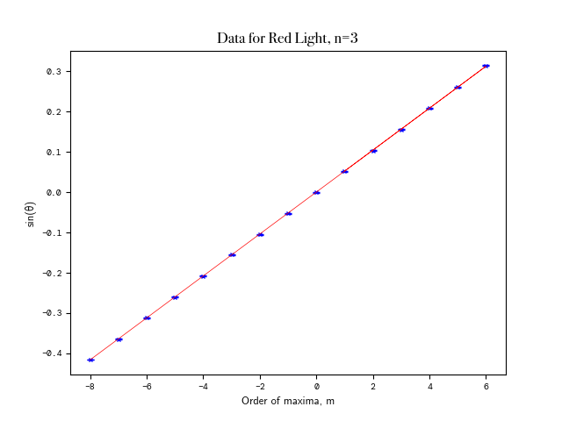

**Red GRAPH**

USING CURVE_FIT METHOD:

Covariance Matrix:

[[2.46037029e-09 2.74391435e-09]

[2.74391435e-09 5.09809716e-08]]

m = 0.05205815098685858 ; σ= 4.9602119764658454e-05

Red λ: (6.606+/-0.006)e-07 ;

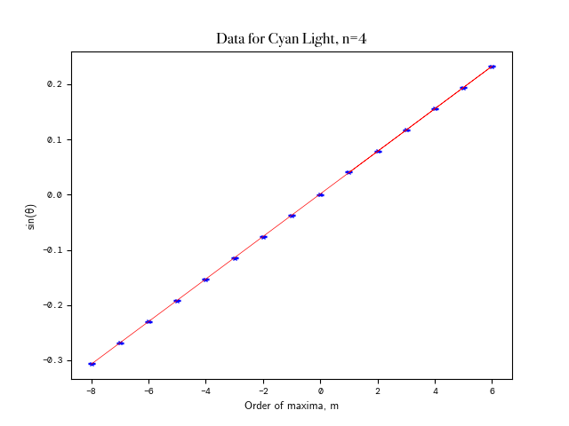

**Cyan GRAPH**

USING CURVE_FIT METHOD:

Covariance Matrix:

[[2.57971393e-09 2.72843418e-09]

[2.72843418e-09 5.21359987e-08]]

m = 0.03854650540385491 ; σ= 5.0790884271663935e-05

Cyan λ: (4.892+/-0.006)e-07 ;

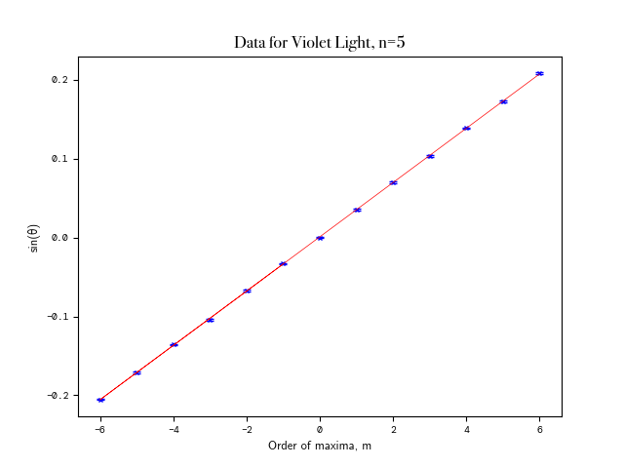

**Violet GRAPH**

USING CURVE_FIT METHOD:

Covariance Matrix:

[[ 4.05949408e-09 -4.73167859e-12]

[-4.73167859e-12 5.75945309e-08]]

m = 0.03443811976874244 ± 6.371415920132723e-05

Violet λ: (4.370+/-0.008)e-07

These results were promising as the wavelengths that we found well within a 5nm range of the values we found from online sources, which corresponds to a <1% percentage uncertainty for each reading.

Errors (σ) in 1/λ respectively (for RED, CYAN, VIOLET):

[1442.2779925756868, 2693.6549855966296, 4233.341554768613]

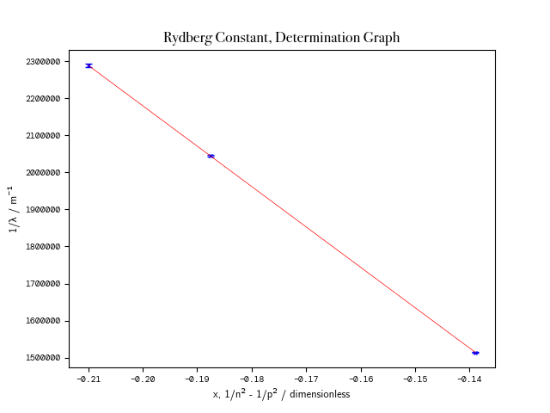

USING CURVE_FIT METHOD:

Covariance Matrix:

[[2.27742095e+09 3.52328010e+08]

[3.52328010e+08 5.59896879e+07]]

Rydberg Constant: 10903019.720248355 ± 47722.33178362809

**A Note on Python Code and Error Propogation**

Using scipy.optimize.curve_fit instead of numpy.polyfit, we were able to take into account the uncertainty associated with each value into our covariance matrix. This was also aided using the python uncertainties package, which propogated the standard deviations of the sine of each angle for us, as well as each subsequent calculation using their proprietary data type, “ufloat”. Consequently, the final covariance matrix obtained was not only from the uncertainty in the final curve_fit, but also from each precedent value. This was factored into our final graph, for each standard deviation value in the 1/λ.

## FINAL GRAPHS

## Error Propagation

gradient_red,gradient_cyan,gradient_violet = ufloat(table[0][0],table[0][1]),ufloat(table[1][0],table[1][1]),ufloat(table[2][0],table[2][1])

unc_red,unc_cyan,unc_violet = (d*gradient_red),(d*gradient_cyan),(d*gradient_violet)

sigma_red,sigma_cyan,sigma_violet = 1/(d*gradient_red),1/(d*gradient_cyan),1/(d*gradient_violet)

sigmaError = [sigma_red.s,sigma_cyan.s,sigma_violet.s]

print("\nRed λ:",unc_red,"; Cyan λ:",unc_cyan,"; Violet λ:",unc_violet)

print("Errors (σ) in 1/λ respectively:",sigmaError)

red,cyan,violet = 1/(d*gradient_red._nominal_value),1/(d*gradient_cyan._nominal_value),1/(d*gradient_violet._nominal_value)

x,y = [1/9 - 1/4, 1/16 - 1/4, 1/25 - 1/4],[red,cyan,violet]

s = np.poly1d(x)

print("USING CURVE_FIT METHOD:")

curvefit,cov_curvefit = curve_fit(functionLinear,x,y,*sigma*=sigmaError,*absolute_sigma*=True)

plt.xlabel("x, 1/n² - 1/p² / dimensionless", **axesFont)

plt.ylabel("1/λ / m¯¹", **axesFont)

plt.xticks(**ticksFont)

plt.yticks(**ticksFont)

plt.ticklabel_format(*style*='plain')

plt.title("Rydberg Constant, Determination Graph", **titleFont)

plt.errorbar(x,y,*yerr*=sigmaError,**errorStyle)

plt.plot(x,y,'x',**pointStyle)

plt.plot(s,curvefit[0]*s+curvefit[1],'r',**lineStyle)

plt.show()

print("Covariance Matrix: \n",cov_curvefit)

print("Rydberg Constant: ",-curvefit[0],"; σ=",np.sqrt(cov_curvefit[0,0]))

Summary

Consequently, from our spectrometer experiment, we obtained that, through the observation of the maxima of different colours in the Balmer series, taking note of their angular displacements from the central maximum, then plotting dsinθ for each colour of the maxima, we could get wavelengths for the colours of light we found: red, cyan and violet. We found that the gradient of the graph of 1/λ against 1/n² - 1/p², where the values of n and p are known, gave us the value of -R∞, so the Rydberg constant could easiy be obtained from this.

Our experimental value for the Rydberg constant was 10903020 m¯¹, with an uncertainty of ± 47722 associated with it. Given the accepted value of the Rydberg constant as 10 973 731.6 m-1, this gives a percentage difference of 0.64% from our experimental value, or within 1.48× the uncertainty range. As a result, our experiment yielded accurate (given the low percentage difference to the accepted value), precise (given that the standard deviation constituted a mere 0.44% of our value) results.

To improve upon the experiment, if time wasn’t as constrained, rather than estimating the uncertainty in the readings for the angles, a range of results over which the maxima occurred could be taken, rather than just for the preliminary readings that we took to obtain an estimate. Furthermore, the effect of these systematic uncertainties could be quantitified, as could the uncertainty and “parallax” error that occurred from reading off the vernier scale, (though we attempted to minimise this through the use of a phone camera to aid us). There was some background light whilst conducting the experiment as well which could’ve been further reduced.